Sociology of Work – Practice Midterm.

The purpose of this document is to help you prepare for the next midterm.
Question 1 has been answered by me and gives you an ideal type answer that would receive high marks across the evaluation criteria:
- Clarity (how clearly does the student express their ideas?)
- Concepts (how well does the student define the relevant concepts?)
- Application (how well does the student apply concepts to understanding the case(s)?)
- Data (how well does the student use relevant data/cases/examples to support their answer?)
(please note that typed text typically takes less space than handwriting. You will have one side of A4 paper for your answer.)
Question 2 gives you a practice question to try by yourself. If this is returned to me I will give feedback within 1 week.

Tips
- Take into account the time and space you have to respond to each question and the number of marks each is worth
- Plan the structure of your answer quickly before you start to write
- Make sure you identify all elements of the question
- Identify and define relevant concepts.
- Avoid generalizations and unjustified opinions, “in my opinion….”
- Use data and examples wherever appropriate to justify your answers.

____________________________________________________________________________________

Question 1. (10 marks)
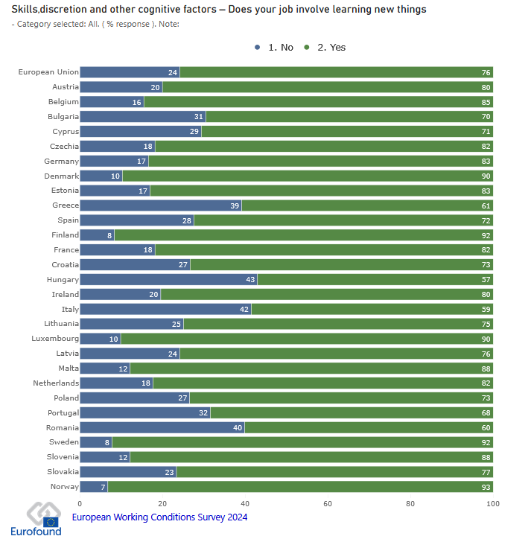
ZOOTOPIA

Surveys on working conditions taken in Zootopia show that workers typically work longer hours than the European average. 43% of workers report that their job doesn’t involve learning new things. A majority of workers in Zootopia claim that they ‘rarely’ or ‘never’ influence decisions that are important to their work.
Based on our discussions on models of organizational management, what model best characterizes Zootopia and why?

Answer 1.
Scholarship on organizations typically distinguishes between three models of management that relate to the approach taken by employers or bosses towards their employees or subordinates. These are the neo-Taylorist model, the lean production model and the humanist or discretionary learning organization.
The neo-Taylorist model is characterised by the dominance of repetitive and low skill tasks. These usually give employees little room to make decisions and have stronger, more formal hierarchies. Organizations that adopt this model usually prioritise the efficiency of tasks over the well-being of employees and are common in countries or sectors that produce goods and services in high volumes.
The lean production model is characterised by a higher degree of flexibility than neo-Taylorist models and as such organizations are often divided into task or project specific teams. These organizations typically operate on a ‘just in time’ basis where supply chains and production are designed to account for minimal holding of stock/resources. Employee tasks may still be routine but within their teams some flexibility in tasks and decision-making may be allowed.
The humanist model closely associates the well being of workers with the efficiency and productive capacity of the organization. It offers workers a high level of autonomy and decision-making capacity, with a high degree of variation in tasks (qualitative flexibility). Workers in these organizations typically operate with higher levels of skills and qualifications, while production is usually concentrated on small batches and highly technical goods.
The data presented above shows that Zootopia is more closely correlated with what we would expect from a neo-Taylorist model. This is apparent in the fact that Zootopian workers will usually work longer hours than the European average. In Zootopia, workers report having low levels of decision-making power and 43% of workers reporting that they don’t learn new things at work – the highest in Europe. These factors would indicate more formal, hierarchical work organizations where workers have little autonomy and suggest that Zootopia is characterised by organizations that use simple, repetitive tasks.

Question 2. (10 marks)
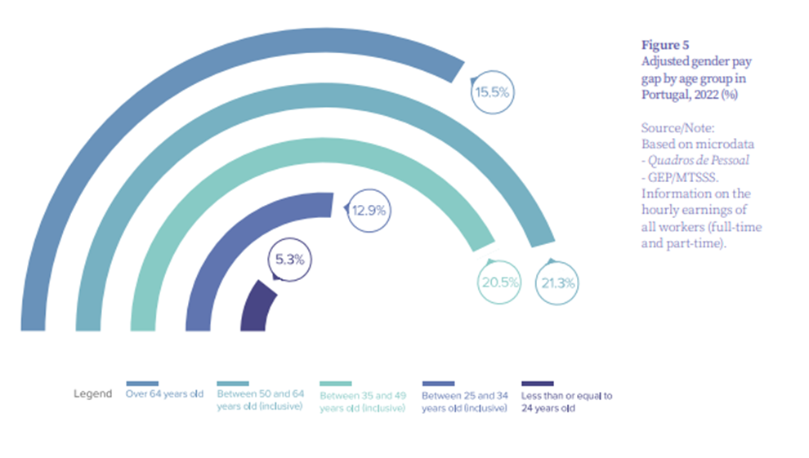
Based on what was discussed in class about the work patterns of men and women in Portugal, what could explain the data shown in the figure above? How would you classify the Portuguese labour market from a gender perspective? Suggest possible policy measures. Justify your answers carefully.

Answer 2.

